

East West University

Department of Computer Science and Engineering
Semester : Spring 2021

Course Title : Electrical Circuits
Course Code : CSE 209
Section: 03

Experiment No : 04
Experiment Title: Bias Point Detail Analysis of DC Circuit With Dependent Sources Using PSpice Schematics

Student Name: Md. Rakibur Rahman
ID: 2019-3-60-113

Date of Performance: 31 - 03 - 2021
Date of Submission: 06 - 04 - 2021
Objectives:
- To analyze Bias Point Detail of DC circuit with dependent source using PSpice Schematics.

Circuit Diagram:
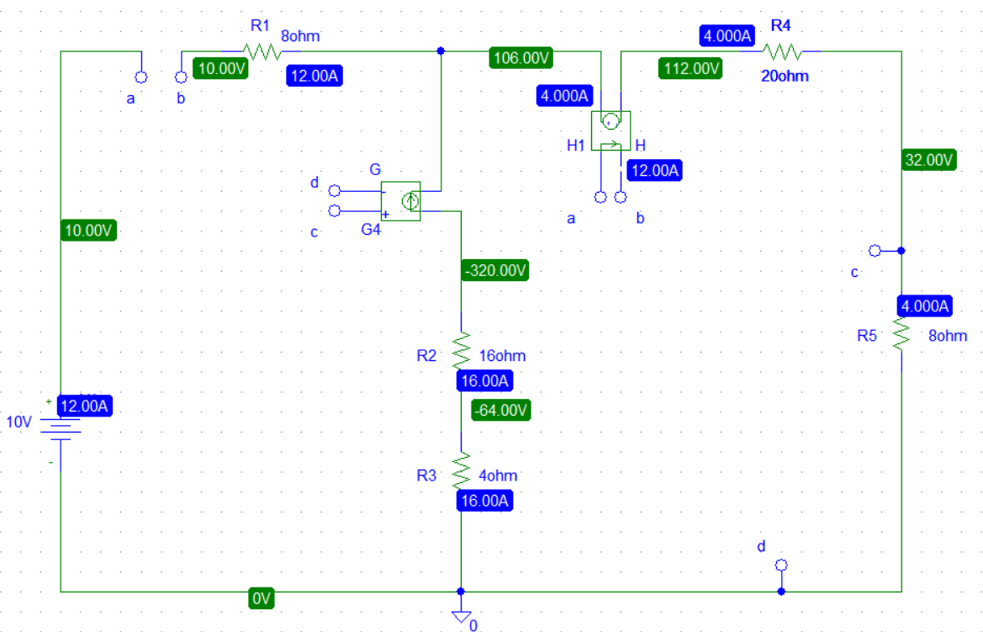

Answers to the post lab report questions:
- Here ,
Is=i₁
V_{ab}=8i₂
Applying KVL at super mesh,
8i₁+20i₂+8i₂=10-0.5I_{s}
8.5i₁+28i₂=10…….(1)
From supermesh,
i₂-i₁= 0.5V_{ab}
i₂-i₁= 0.5$×$8i₂
i₂-i₁-4i₂=0
i₁-3i₁=0………(2)
From Equation 1& 2 we get,
i₁=-12 A
i₂=4 A
I_{s}=i₁=-12 A
V_{ab}=8i₂=8$×$4=32V

2.As the experiment was done in the pspice . so there is no discrepancy in the experimental values.
The experimental values of the voltages and the currents are exactly same with the theoretical values.

Conclusion:
In this experiment, we learnt about 4 types of dependent sources which are VCVS, CCCS,VCCS & CCVS. We used bubble for easier interconnections. And learnt how to do mesh analysis. Also there was no discrepancy as the experiment was done in PSpice .

